National College of Computer Studies
(NCCS-College of IT & Management)
Paknajol, Kathmandu


A Lab Report of
“Data Structures and Algorithms”
B.Sc. CSIT 3rd Semester

Submitted by: Submitted to:
Aarya Manandhar Khushbu Sarraf
Roll No.: 01 Lecturer, BSc. CSIT
Section: A
Email: aaryamanandhar2060@gmail.com

DECLARATION
I hereby declare that the project work entitled “PAC-MAN” submitted to Institute of Science and Technology, Tribhuvan University, Kathmandu. National College of Computer Studies, Kathmandu, is for the degree is submitted in partial fulfillment of requirements for the degree of Bachelor of Science in Computer Science and Information Technology (B.Sc.CSIT). This report contains all the original research and analysis with some information taken from other resources which are properly cited. This project work has not been submitted to any other university or institution for the award of any degree or diploma.

ACKNOWLEDGEMENT

This report is my assignment as a partial fulfillment of project work course for the requirement of Bachelor of Science in Computer Science and Information Technology (B.Sc.CSIT). I have taken this opportunity to express my respect and gratitude to my respected teacher Mrs. Khushbu Sarraf for their valuable guidance in making this project a reality. I am thankful for their constant support and encouragement and valuable guidance and encouragement throughout this project completion period. I am also thankful to the lab teacher Mr. Samrat Singh for her help during the completion of the project. I would like to present my teachers gratitude for their guidance, good advices and honest reviews in this entire project session. Project has been completed under the intensive and genuine guidance of National College of Computer Studies.

ABSTRACT

The Pac-Man game is a classic arcade title renowned for its simple yet addictive gameplay. In this adaptation, players control a character navigating a maze, collecting dots while avoiding enemy entities. The goal is to clear each level by eating all the dots, while strategically evading enemies to prevent losing lives. Our implementation captures the essence of the original game, offering an engaging experience through its familiar mechanics and challenging levels. With its retro charm and timeless appeal, Pac-Man continues to captivate players of all ages, making it a beloved icon in the world of video games.

Table of Contents
1. INTRODUCTION 1
2. BACKGROUND 1
3. PROJECT STRUCTURE 1
3.1. Game Display: 1
3.2. Instructions: 2
3.3. Difficulty Selection: 3
3.4. Score Display: 3
3.5. Game Over Message: 4
4. TECHNICAL DETAILS 4
4.1. C++ Language: 4
4.2. Object-Oriented Programming (OOP): 4
4.3. Game Logic and Control: 4
4.4. Console Interaction: 5
4.5. Game Rendering: 5
4.6. Pathfinding Algorithm: 5
5. CODE STRUCTURE 5
5.1. Main Functionality 5
5.2. Game Entities and Logic 7
5.3. Console Interface Design 7
5.4. User Input Handling 8
5.5. Game Logic and Control 8
6. FURTHER ENHANCEMENTS 9
7. CONCLUSION 10

INTRODUCTION
Pac-Man, originally known as Puck Man in Japan, is a classic maze action video game developed and released by Namco for arcade machines in 1980. In North America, Midway Manufacturing released the game under a licensing agreement with Namco America. The game is implemented in C++ to replicate the arcade experience on computer systems. In this C++ implementation, the player controls Pac-Man, a character represented by a sprite that moves through a maze. The objective is to guide Pac-Man to eat all the dots scattered throughout the maze while avoiding four ghosts. The maze is enclosed, creating a challenging environment for the player to navigate.
In the C++ version of Pac-Man, the game's mechanics are faithfully recreated, including the maze layout, ghost behavior, and scoring system. The implementation leverages object-oriented programming principles to manage game entities such as Pac-Man, ghosts, and pellets.

BACKGROUND
Early in 1979, Toru Iwatani and a group of nine developers started working on Pac-Man. Since most video games at the time had themes related to sports or warfare, Iwatani set out to build a game that would appeal to a wider audience, including women. Iwatani set out to create a game that would appeal to younger players by using adorable and vibrant characters in order to do this. The picture of a pizza with a slice cut off served as the model for the main character, Pac-Man. Iwatani, however, chose to soften the curve such that it resembled the Japanese character "kuchi", which means mouth. Pac-Man's unique form was created by this design decision, and it has since grown to be recognized in the gaming industry.

PROJECT STRUCTURE

Game Display:
The game map is displayed using ASCII characters, representing walls, empty spaces, dots, the player character, and the enemy character. The map is refreshed periodically to reflect changes in the player's position, score, and enemy movement.
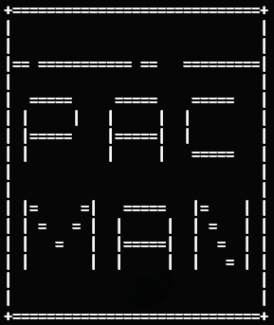
Figure 1: Game Display

Instructions:
Upon starting the game, instructions are displayed on the console interface to guide the player on how to play. Instructions typically include information on controlling the player character using arrow keys, collecting points, and avoiding enemies.
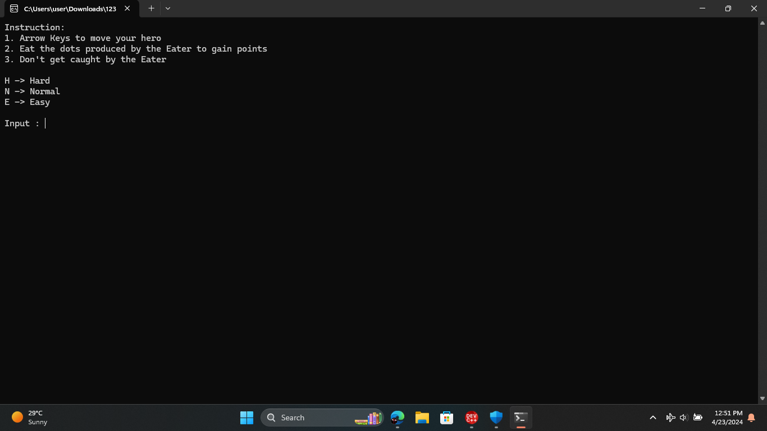
Figure 2: Instructions

Difficulty Selection:
After displaying instructions, the game prompts the player to select a difficulty level (Easy, Normal, or Hard). The player inputs their choice using keyboard input.
Figure 3: Level Selection

Score Display:
The player's current score is displayed on the console interface, typically in a designated area of the screen. The score is updated in real-time as the player collects points during gameplay.
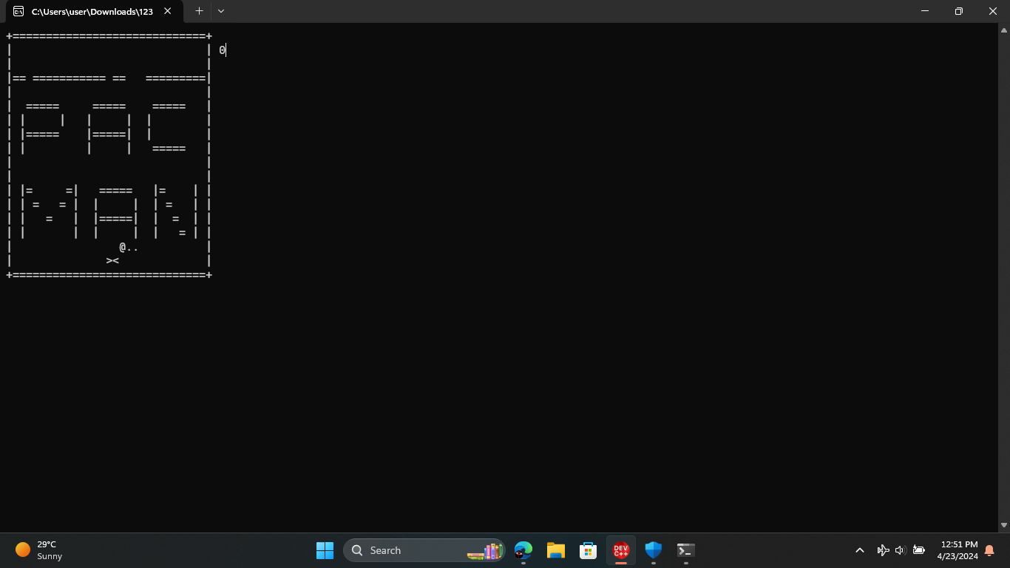
Figure 4: Score Board

Game Over Message:
When the game ends (either by the player losing or winning), a game over message is displayed on the console interface. The message usually includes the player's final score and possibly a congratulatory or commiserative message.
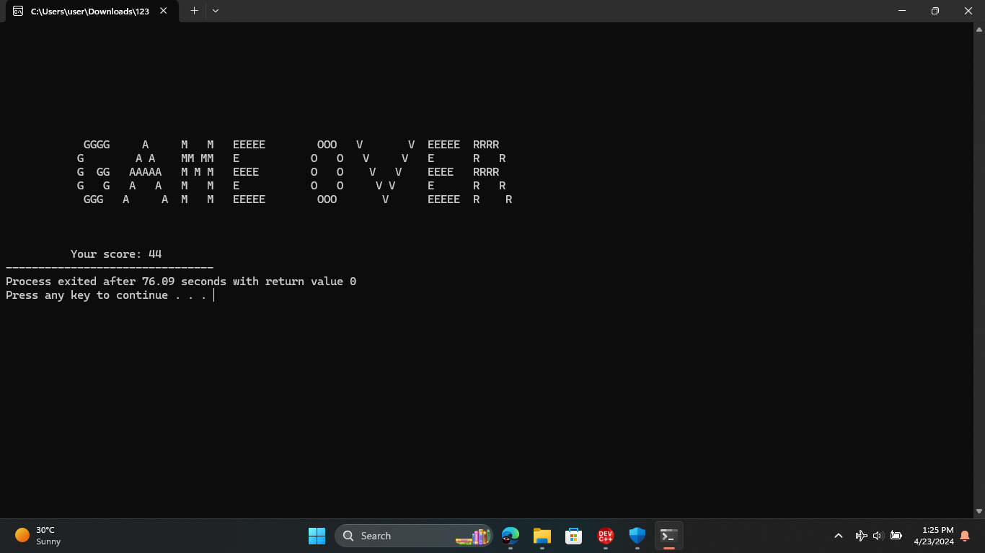
Figure 5: Game Over

TECHNICAL DETAILS

C++ Language:
The project is written in C++, utilizing core language features such as functions, loops, conditional statements, and arrays. It includes standard C++ libraries like <iostream>, <stdio.h>, <string>, <vector>, <cstdlib>, and <ctime>.

Object-Oriented Programming (OOP):
The code exhibits procedural programming rather than a strict object-oriented approach. While there are no explicit classes, the code segments related to entity movement and pathfinding could be organized into classes to adhere to an OOP paradigm.

Game Logic and Control:
The game logic is implemented to simulate the classic Pac-Man gameplay. Player movement is controlled by keyboard input, allowing the player to navigate the maze. Dots are scattered throughout the maze for the player to collect, increasing their score. Enemy movement is governed by a pathfinding algorithm (BFS) to chase the player character.

Console Interaction:
Console interaction is achieved using C++ libraries like <windows.h> and <conio.h>.Functions like gotoxy() are used to position the cursor on the console window, enabling dynamic rendering of game elements.Keyboard input is detected using GetAsyncKeyState() from <windows.h>, allowing real-time response to player actions.

Game Rendering:
The game map is represented using a two-dimensional character array (char map[18][32]).The map is displayed on the console using the ShowMap() function, which iterates through the array and prints each row.

Pathfinding Algorithm:
The game employs a simple breadth-first search (BFS) algorithm to find the shortest path from enemies to the player. The BFS algorithm is implemented in the FindPath() function, which populates a queue (walk_queue) with target positions for enemy movement.

CODE STRUCTURE
The Pac-Man game project is structured to maintain modularity and clarity, employing object-oriented programming (OOP) principles for better organization and ease of maintenance.

Main Functionality
The main () function serves as the entry point of the program and manages the execution flow of the Pac-Man game. It handles initialization tasks, user input processing, game state management, and termination conditions.
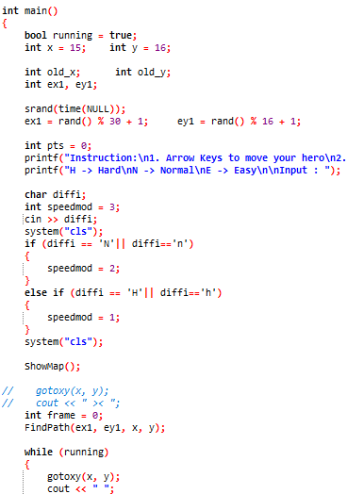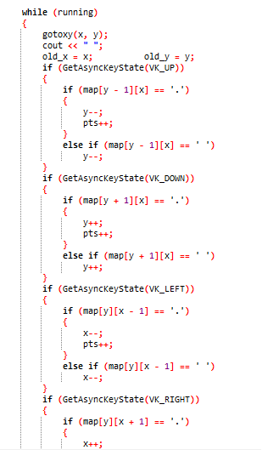

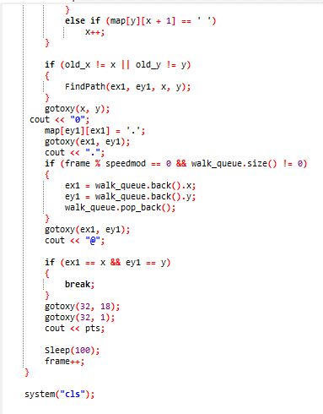

Game Entities and Logic
The Pac-Man game features several core entities, including Pac-Man itself, ghosts, pellets, and the maze. These entities are implemented as classes or structures, each responsible for specific game behavior.
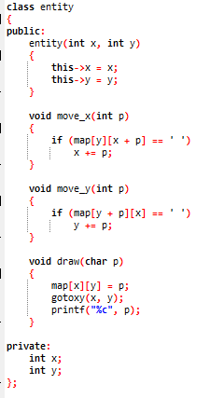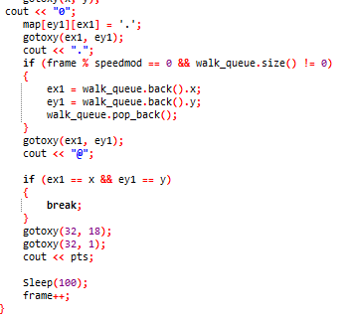

Console Interface Design
The ShowMap() function is responsible for rendering the maze and game entities onto the console screen. It utilizes ASCII characters to represent the maze layout and graphical elements such as Pac-Man, ghosts, pellets, and power pellets.
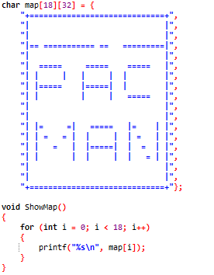

User Input Handling
User input is essential for controlling Pac-Man's movement within the maze. The project utilizes keyboard input functions such as GetAsyncKeyState() to capture arrow key presses, allowing real-time control over Pac-Man's direction.
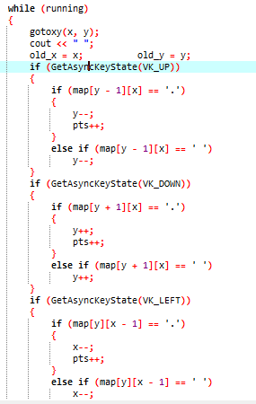

Game Logic and Control
The Pac-Man game implements classic gameplay mechanics, including Pac-Man's movement, ghost behavior, pellet consumption, scoring, and power-up effects. These game mechanics are encapsulated within the respective classes and functions, ensuring cohesive and well-defined behavior.

1. ShowMap (): Displays the game map (maze) on the console.
2. gotoxy (short x, short y): Positions the console cursor to specified coordinates (x, y).
3. FindPath (int sx, int sy, int x, int y): Finds the shortest path between Pac-Man and the ghosts using Breadth-First Search (BFS) algorithm.
4. AddArray (int x, int y, int wc, int back): Adds elements to an array used in the BFS algorithm.
5. main (): Entry point of the program manages game initialization, rendering, user input handling, and game loop execution.

FURTHER ENHANCEMENTS

1. Game Over Condition: Added to provide closure and end the game when appropriate.
2. Levels and Difficulty Settings: Introduced to offer depth and variation in gameplay.
3. Sound Effects and Music: Implemented to enhance immersion and engage players.
4. Scoreboard and High Scores: Included to encourage competition and replay ability.
5. Improved User Interface: Enhanced to create a more polished and enjoyable experience.
6. Overall Enhancement Goal: Aimed at providing a captivating and lively gaming experience for both casual and enthusiast players.

CONCLUSION
This code represents a basic console game that resembles Pac-Man. The entities and gaming environment are represented by simple ASCII characters. Using the arrow keys, the player controls a character ('0') who must avoid adversaries ('@') and gather dots ('.'). When the player collides with an adversary, the game is over. The code is functional, but it is devoid of sophisticated features like many levels, dynamic opponent behavior, or a score system. To make the code easier to read and maintain, it may also use some better organization and commenting.

